September 2018
Sun | Mon | Tue | Wed | Thu | Fri | Sat
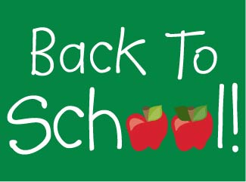 |  |  |  |  |  | 1
2 | 3  Labor Day  School CLOSED | 4  Pancakes  Sausage  Fruit  Vegetable  Milk | 5  Cheeseburger  French Fries  Apple Slices  Vegetable  Chocolate Milk | 6  Pasta & Meatballs  Marinara Sauce  Fruit  Vegetable  Milk | 7  Pizza  Fruit  Vegetable  Milk | 8
9 | 10  Chicken Nuggets  Fruit  Vegetable  Milk | 11  Pancakes  Sausage  Fruit  Vegetable  Milk | 12  Cheeseburger  French Fries  Apple Slices  Vegetable  Chocolate Milk | 13  Pasta & Meatballs  Marinara Sauce  Fruit  Vegetable  Milk | 14  Pizza  Fruit  Vegetable  Milk | 15
16 | 17  Chicken Nuggets  Fruit  Vegetable  Milk | 18  Pancakes  Sausage  Fruit  Vegetable  Milk | 19  Cheeseburger  French Fries  Apple Slices  Vegetable  Chocolate Milk | 20  Pasta & Meatballs  Marinara Sauce  Fruit  Vegetable  Milk | 21  Pizza  Fruit  Vegetable  Milk | 22
23/30 | 24  Chicken Nuggets  Fruit  Vegetable  Milk | 25  Pancakes  Sausage  Fruit  Vegetable  Milk | 26  Cheeseburger  French Fries  Apple Slices  Vegetable  Chocolate Milk | 27  Pasta & Meatballs  Marinara Sauce  Fruit  Vegetable  Milk | 28  Pizza  Fruit  Vegetable  Milk | 29

